Team 3 - Monday Night 9pm Live Session

Assignment: Homework 2

Members: Augustine Fabian, Blake Lattier, Bobby Schaible, Scott Snow, Thomas Freitas

**Question 1. What were the time frames for each marketing campaign? How much was spent on each campaign? What was the effectiveness of previous campaigns?**

**a. Whitman.syr.edu**

The total cost for this campaign, which ran from February 22, 2011 to August 27, 2011, was $37,851.36. Out of the three google campaigns, this one yielded the highest clicks and sessions while also producing the lowest cost per click and overall cost. In addition to the cost and click metrics, the bounce rate and pages per session were significantly better than the other two campaigns. These user metrics are representative of a more engaged audience that is interested in the product.

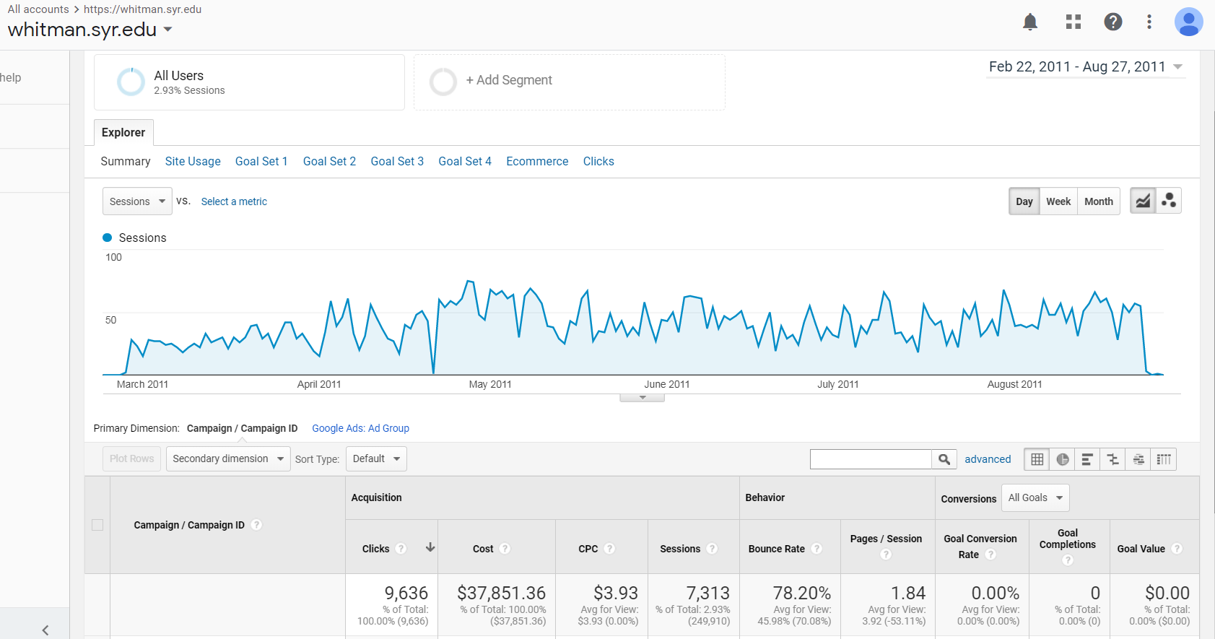

**b. MBA Marketing – Full-time**

The total cost for this campaign was $78,338.06. The campaign was identified as running in two distinct segments 1 from January 17, 2012 to Feb 2, 2012 and then again from October 24, 2012 to July 2, 2013. In analyzing the campaign, our team noticed that the main portion of this campaign (segment 2 pictured below) had a cost per click of almost 3 times higher than the whitman.syr.edu campaign. Additionally, this campaign also resulted in higher bounce rates and lower pages per session metrics. High bounce rates and low pages per sessions are indicative of an audience that has not been targeted effectively. We concluded that the campaign was drawing in a majority of visitors that were not interested in a full-time MBA.

*Segment 1*

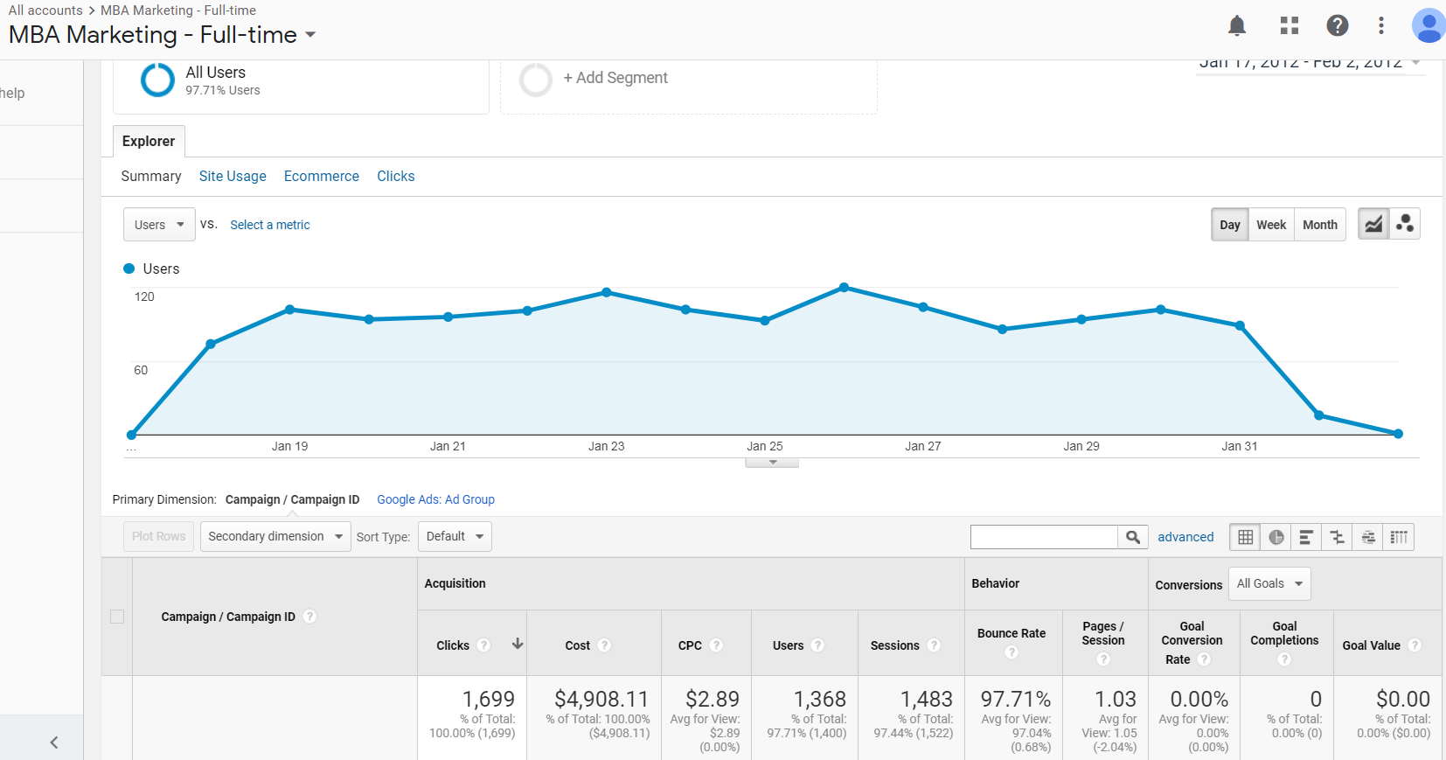

*Segment 2*

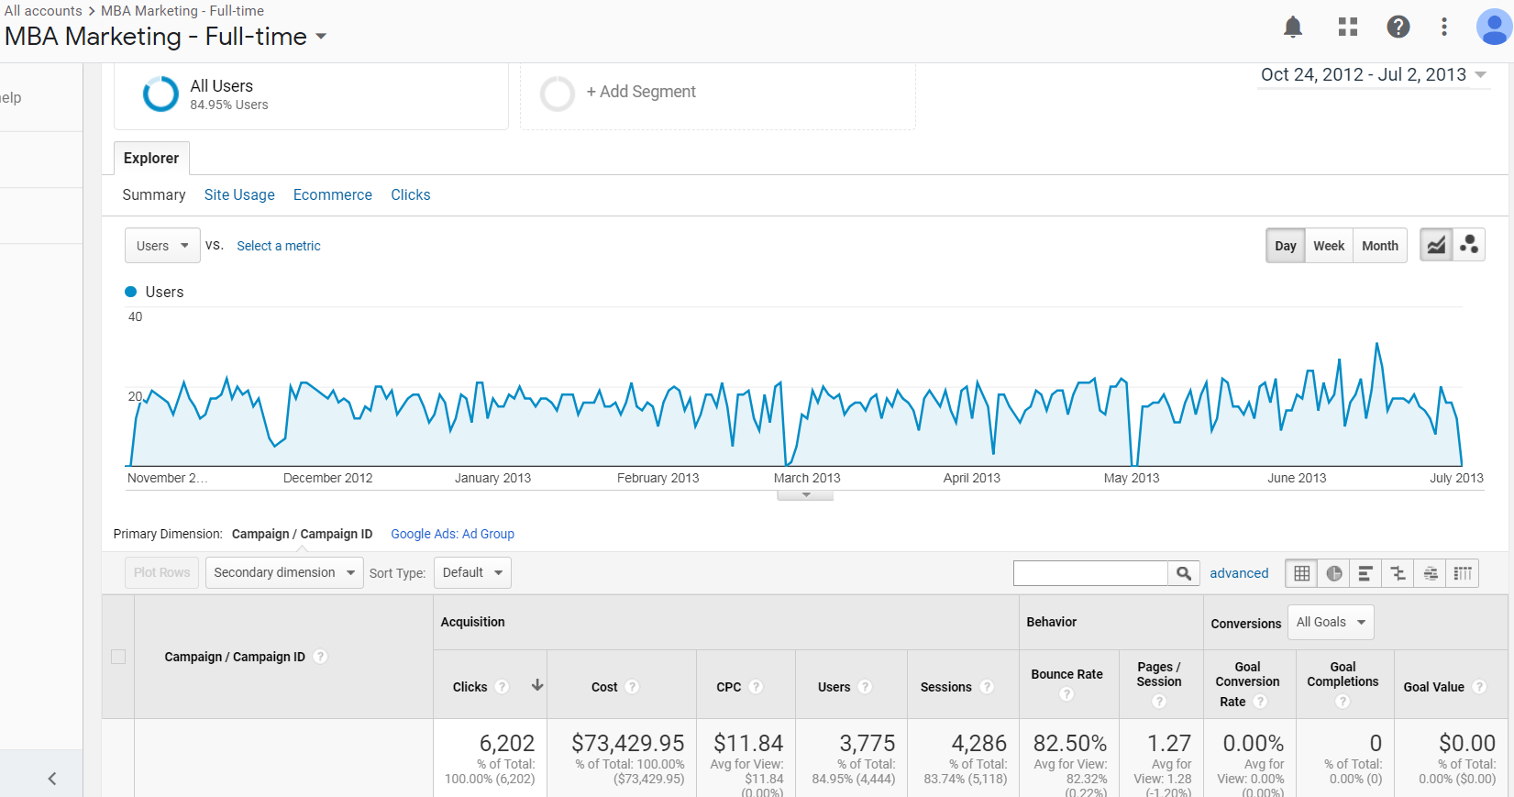

**c. MBA Marketing – iMBA**

The total cost for this campaign was $81,554.77. It ran from January 30, 2012 to October 27, 2012. Compared to the other two google campaigns, this performed the worst. It generated a 17% higher cost per click, had the highest bounce rate, the lowest pages per session, and generated the lowest total sessions.

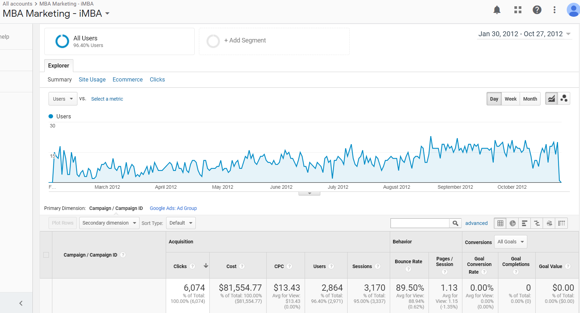

**d. Delta**

The Delta advertisement cost was $10,000 and lasted from September 22, 2013 to November 15, 2013. While the Delta campaign did attract prospects that were highly engaged, with a bounce rate of only 32% and pages per session at 3.17, it did not generate anywhere near the volume of users or sessions as the other campaigns.

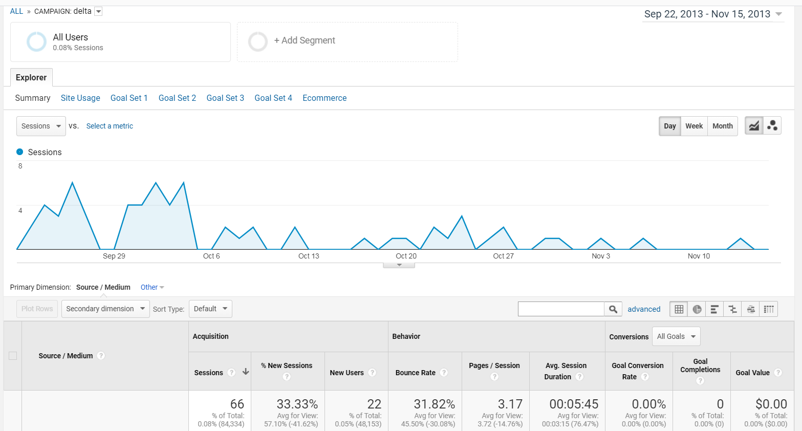

**Question 2. Identify the key aspects of a United States campaign for next year**

**a. In which geographic region would you advertise? Which states? Why?**

After analyzing the location data of our audience, we decided to break the country into four regions as defined by the U.S. Census Bureau: Northeast, South, Midwest, and West (https://www2.census.gov/geo/pdfs/maps-data/maps/reference/us_regdiv.pdf). The analysis was established using the session metrics generated by the states in each region. We sorted states by sessions because the session metric captures the most information about user engagement in one session. We assumed that high session metrics correlated to highly engaged students which, in turn, correlated with admitted students. The screenshot below illustrates the breakdown of regions by state.

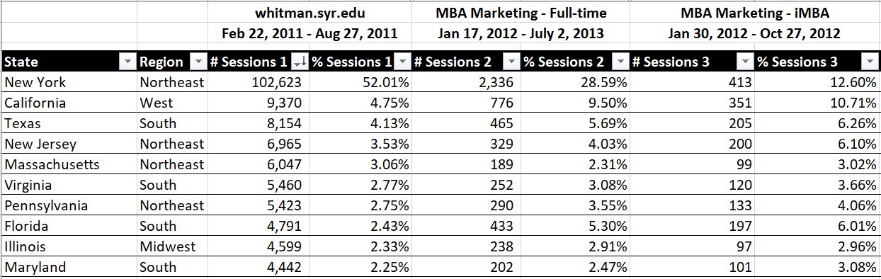

**b. What keywords would you use? Why?**

We analyzed keywords from each campaign and selected keywords that would yield a high number of both sessions and pages per session, and a low bounce rate. The table below summarizes the main three keywords that we would use in our campaigns and their summary statistics. Our team decided to exclude any keywords that included “no GMAT” or “GMAT waiver” in order to attract students who likely had higher GMAT scores and were not looking for a waiver.

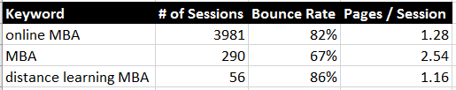

**c. Which days of the week and what time of day would you advertise? Why?**

Initially, we will blanket the most common time frames for internet traffic. Specifically evenings between 5 pm and midnight. Based on the CPC of the original campaigns, our budget allows flexibility. A modest initial estimate of $74,300 for the year allows us flexibility in case our campaign proves to be more successful. Furthermore, our analysis indicates a few timeframes in that window that we will not be advertising in. These are indicated by red boxes in the Advertising Time Analysis chart below. Additionally, our analysis indicates that any advertisement outside of that time frame results in either not enough traffic to justify it, or more commonly, too high of a bounce rate. Although analysis was not done, it is logical to conclude that users who visit more than one page are much more likely to enroll and those who don’t. The most important aspect of doing this analysis is so that we are not paying for clicks likely to result in a bounce.

As our campaign is in progress, we can measure the results and determine whether our current approach is correct or narrow our schedule to what the analysis indicated in the case of a smaller budget which would correspond to an increase in clicks for this campaign. Below is the ideal schedule we would follow if we are not bound by how many clicks we are expecting to receive. Our metrics were specifically a session count greater than 100 or a bounce rate less than 80%. Finally, we would attempt to not advertise on holidays when we expect people in general to more likely not be on their computers or internet browsing on their smart device.

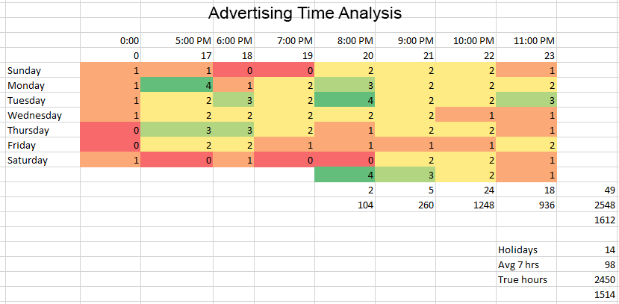

This second figure is a data table for the results we could expect assuming our number of clicks stay the same. Here, we would seek to improve our margin by decreasing the bounce rate while increasing the hours advertised. The output is the number of sessions that did not bounce. Our initial values are taken from the original campaign output.

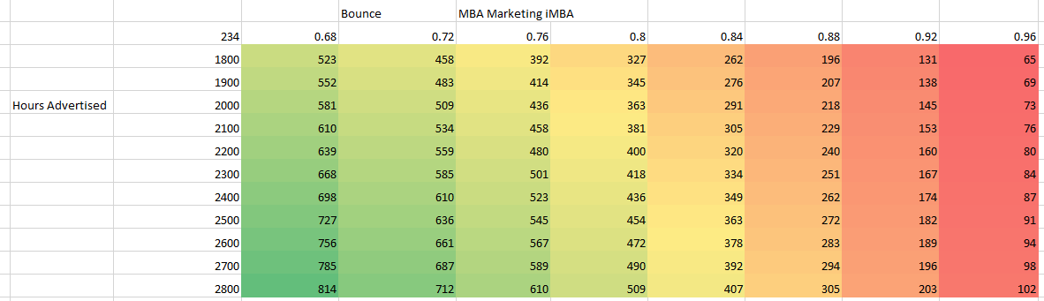

**Question 3. Identify the costs for your advertising campaigns**

**a. By region:**

To determine the budget allocation per region, the total sessions per location across each degree program campaign were analyzed. The results are as follows:

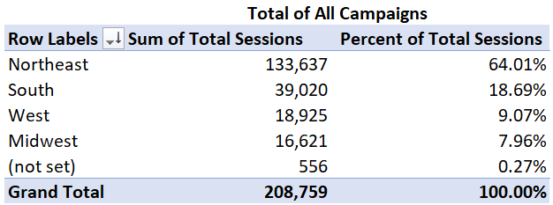

Based off of these numbers, it was determined that 60% of the budget would be applied to the Northeast, 20% to the South, 10% to the West and 10% to the Midwest. Total dollar allocation is shown in the figure below:

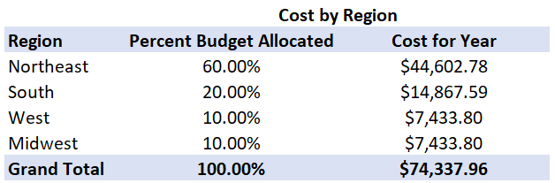

**b. By degree program**

To gauge each region’s interest across all degree programs, the session numbers per campaign were normalized per 1000 sessions. This allowed for us to accurately measure each campaign against each other. The chart below shows the proportion of interest amongst each region. For example, 48% of Northeasterners were interested in the whitman.syr.edu compared to 21% being drawn to the iMBA campaign.

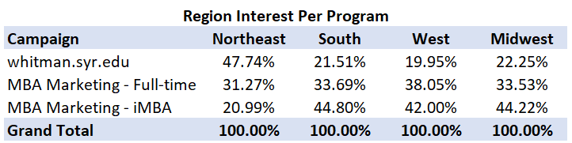

Using these percentages allows us to allocate the previously determined budgets for each region across the three different degree programs. The dollars allocated to each degree are show here:

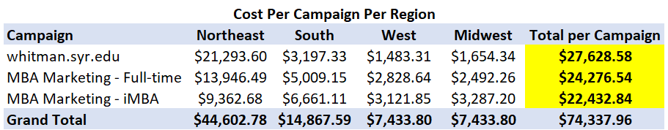

**Question 4. How would you measure performance of your decisions after implementation?**

We would measure the performance of our chosen advertising schedule by using a 2-sample t-test between the desirable metrics we identified from the original campaigns for time of day analysis (bounce rate and sessions). Each month the data can be generated and tested against the original set. If we fail to reject, we know that our advertising schedule was not incorrect. If we do reject the null hypothesis for a two-tail test, then we would do further analysis to either conclude that our schedule is correct but our improved selection in region and keywords caused the rejection. Or we are doing more poorly than the original campaigns and we need to greatly rethink not only our schedule but also other aspects of our strategy as well.

**Question 5. What other factors or considerations are important? What other data would help in developing an Internet advertising strategy, if you could collect it?**

The behavior flow would be important because you can understand the behavior of the individual (see below). We can look at each of the individual subdirectories on the website as to where the traffic is coming from and going to. Exit Pages will also be helpful, it would let us know the last page a person looked at before leaving. Capturing this information will present a better perspective on what a potential student looking for in a university so that we can develop a better campaign strategy. Another helpful data point would be the down funnel conversions of students that enter into the campaign. Ultimately we would want to tie success metrics from google to if the students were enrolling in the program or not. This would help us better target from a demographic standpoint as well as a google metric standpoint. For example, we might find that students with an average of 5 pages per session were much more likely to enroll in the program. One additional thing that would have been helpful in researching time analysis is if there was a schedule for the original campaigns and what it was.

